AI/ML MARKETING CAMPAIGN INTELLIGENCE
Final Project Report
End-to-End Machine Learning System for Campaign Performance, Classification, Audience Segmentation and Anomaly Detection
Dataset: Nykaa Marketing Campaign Data
Records analysed: 55,555
Analysis period: 01 July 2024 – 24 June 2025
Project domain: Artificial Intelligence & Machine Learning
By: Dakshi Vashishtha

1. Executive Summary
This project develops an end-to-end AI/ML Marketing Campaign Intelligence system using 55,555 historical campaign records. The system follows the assignment workflow from data cleaning and exploratory analysis through KPI engineering, predictive modelling, classification, audience segmentation, anomaly detection and a reusable prediction pipeline.
The final revenue-prediction model selected for deployment is Linear Regression. On the testing set it achieved RMSE 231,673.77, MAE 155,284.46, and R² 0.7779. For the classification task, Random Forest was selected using cross-validation, with mean macro-F1 0.7837 and test F1 0.7935.
The final audience segmentation solution uses K-Means with three behavioural segments based on Engagement Score, Conversion Rate and Lead Rate. The selected solution has silhouette 0.3398, Davies-Bouldin 1.0759 and bootstrap stability ARI 0.9892. The three interpreted segments are Highly Engaged Audience, Potential Customers and High Conversion Audience.
The anomaly component combines robust statistical checks and Isolation Forest. In the final Notebook 7 results, 7,139 campaigns were flagged by both methods, 2,052 by the statistical method only, and 5,118 by Isolation Forest only. The combined approach therefore distinguishes high-confidence anomalies from multivariate-only or single-method signals.
Finally, the prediction pipeline integrates all four ML components and generates revenue, performance tier, audience segment, anomaly confidence and marketing insight for new campaigns. A five-row pipeline demonstration was successfully scored, providing a practical example of how the trained system can support marketing decisions.

Project Outcome at a Glance
Component | Final Result
Dataset | 55,555 campaigns × 16 original columns
Feature-engineered dataset | 55,555 rows × 53 modelling features
Revenue model | Linear Regression
Revenue R² | 0.7779
Classification model | Random Forest
Classification test F1 | 0.7935
Audience segmentation | K-Means, k=3
Segmentation silhouette | 0.3398
Anomaly methods | Robust statistical detection + Isolation Forest
Reusable pipeline | Implemented and self-checked

2. Dataset Understanding
The raw dataset contains 55,555 campaign records and 16 columns. The data covers the period from 01 July 2024 to 24 June 2025. It includes campaign descriptors, audience/channel information, funnel volumes, revenue, acquisition cost, ROI, engagement and date information.
Field | Description
Campaign_ID | Unique campaign identifier
Campaign_Type | Email, Influencer, Paid Ads, SEO or Social Media
Target_Audience | Declared campaign audience
Duration | Campaign duration
Channel_Used | One or more marketing channels
Impressions / Clicks / Leads / Conversions | Marketing funnel volumes
Revenue | Observed campaign revenue
Acquisition_Cost | Cost field used in the project spend reconstruction
ROI | Observed ROI field
Language | Campaign language
Engagement_Score | Campaign engagement measure
Customer_Segment | Declared customer segment
Date | Campaign date

Data Quality Findings
- No missing values were present in the raw dataset.
- No duplicate rows were identified.
- No invalid dates were found; dates were converted to datetime for temporal analysis.
- No negative values were found in the core operational metrics such as duration, impressions, clicks, leads, conversions, revenue or acquisition cost.
- ROI contained 13,220 negative values; this was retained as an observed metric rather than automatically removed.
- Logical funnel checks found no cases where Clicks > Impressions, Leads > Clicks or Conversions > Leads.
- Potential IQR-style outliers were identified in Clicks (311), Leads (1,776), Conversions (2,333), Revenue (3,156), Acquisition Cost (4,845) and ROI (4,081). These were treated as potentially informative observations rather than blindly deleted.

3. Data Cleaning and Preprocessing
The cleaning stage was designed to make the dataset ML model ready. The notebooks first validated schema, data types, missingness, duplicates, date validity, logical funnel relationships and negative values. The resulting cleaned dataset retained all 55,555 records.
Quality Check | Result
Check | Result
Rows | 55,555
Columns | 16
Missing values | 0 across all columns
Duplicate rows | 0
Invalid dates | 0
Clicks > Impressions | 0
Leads > Clicks | 0
Conversions > Leads | 0
Infinite values | 0
Cleaned output | nykaa_campaign_cleaned.csv

Outlier Handling Philosophy
The exploratory notebooks identified potential outliers but did not simply remove them. This is appropriate for campaign data because unusually high acquisition costs, revenue, CPC or ROAS can represent genuine campaign events. Instead, anomaly detection was separately developed to identify unusual behaviour in a business-oriented way.

4. Marketing KPI Analysis
The project calculated standard marketing KPIs and additional funnel metrics. The assignment specifies CTR, Conversion Rate, CPC, CPA and ROAS as core KPIs.
Metric | Formula | Meaning
KPI | Formula used in the project | Interpretation
CTR | Clicks / Impressions × 100 | Percentage of impressions generating clicks
Conversion Rate | Conversions / Clicks × 100 | Percentage of clicks producing conversions
CPC | Spend / Clicks | Cost associated with each click
CPA | Spend / Conversions | Cost associated with each conversion
ROAS | Revenue / Spend | Revenue generated per unit of reconstructed spend
CPL | Spend / Leads | Cost per lead
Lead Rate | Leads / Clicks × 100 | Percentage of clicks producing leads
Lead-to-Conversion Rate | Conversions / Leads × 100 | Conversion efficiency after lead generation

Important Spend / CPA Note
In this project, total Spend is reconstructed as Acquisition_Cost × Conversions. The pipeline implements this directly. Therefore, when CPA is calculated as Spend / Conversions, CPA algebraically equals Acquisition_Cost. ROAS remains a separate metric calculated as Revenue / Spend. This distinction is important when interpreting the KPI table and the segmentation outcome tests.
Metric | Value
Aggregate KPI | Value
CTR | 8.51%
Conversion Rate | 22.03%
Lead Rate | 40.04%
Lead-to-Conversion Rate | 55.02%
Total reconstructed Spend | 9,699,124,862.74
Total Revenue | 28,656,364,282.00
Overall reconstructed ROAS | 2.95
Overall CPC | 37.24
Overall CPA | 169.03
Overall CPL | 93.00

Funnel Findings
The aggregate funnel retains 8.51% of impressions as clicks, 40.04% of clicks as leads, and 55.02% of leads as conversions. The largest relative drop occurs from impressions to clicks, where the observed drop-off is 91.49%.
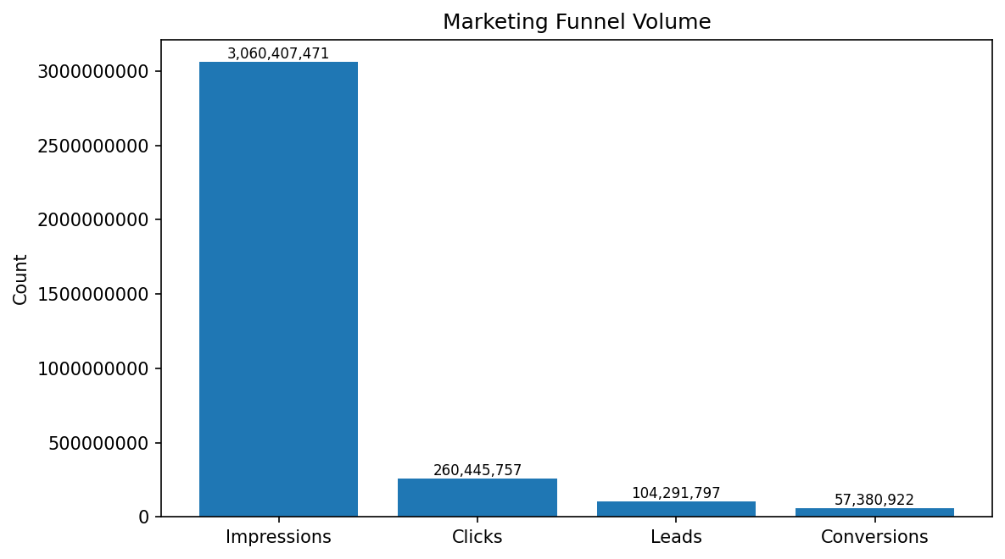
Figure 1. Aggregate campaign funnel volume.

5. Exploratory Data Analysis (EDA)
EDA examined campaign performance, channel and audience behaviour, funnel metrics and relationships among the numerical variables. The data shows substantial variation in revenue, acquisition cost, CPC, CPA and ROAS, while engagement and funnel-rate metrics provide behavioural signals for ML.
Metric | Mean | Median | Min | Max
Metric | Mean | Median | Minimum | Maximum
Impressions | 55,088 | 55,182 | 10,001 | 100,000
Clicks | 4,688 | 3,907 | 202 | 14,868
Leads | 1,877 | 1,481 | 56 | 8,876
Conversions | 1,033 | 779 | 19 | 6,686
Revenue | 515,819.72 | 360,436.00 | 6,183.00 | 4,579,910.00
Acquisition Cost | 377.35 | 207.51 | 9.08 | 15,473.16
ROI | 2.71 | 1.24 | -0.97 | 74.42
Engagement Score | 13.78 | 13.60 | 2.60 | 30.91

Campaign Type Performance
Campaign Type | Avg Revenue | Avg ROAS | Avg CTR | Avg Conv. Rate | Avg CPC | Avg CPA
Social Media | 517,531 | 3.75 | 8.54% | 21.92% | 68.36 | 373.26
Paid Ads | 517,405 | 3.72 | 8.51% | 21.81% | 69.30 | 379.13
SEO | 514,381 | 3.71 | 8.45% | 22.05% | 69.57 | 378.74
Influencer | 518,148 | 3.70 | 8.56% | 22.01% | 69.25 | 375.49
Email | 511,624 | 3.68 | 8.47% | 22.08% | 70.42 | 380.13

Target Audience Performance
Target Audience | Avg Revenue | Avg ROAS | Avg CTR | Avg Conv. Rate | Avg CPC | Avg CPA
Premium Shoppers | 523,367 | 3.80 | 8.53% | 22.06% | 68.48 | 373.61
College Students | 522,319 | 3.74 | 8.55% | 22.05% | 68.94 | 371.28
Tier 2 City Customers | 513,609 | 3.68 | 8.50% | 21.93% | 69.66 | 379.83
Youth | 507,981 | 3.68 | 8.43% | 21.96% | 70.59 | 384.65
Working Women | 511,735 | 3.67 | 8.54% | 21.85% | 69.25 | 377.46

Customer Segment Performance
Customer Segment | Avg Revenue | Avg ROAS | Avg CTR | Avg Conv. Rate | Avg CPC | Avg CPA
Working Women | 522,514 | 3.77 | 8.57% | 21.89% | 68.77 | 377.59
Premium Shoppers | 516,313 | 3.72 | 8.47% | 22.05% | 69.77 | 377.78
College Students | 513,548 | 3.70 | 8.48% | 22.09% | 70.31 | 379.00
Tier 2 City Customers | 517,817 | 3.70 | 8.54% | 22.01% | 69.43 | 376.94
Youth | 508,945 | 3.68 | 8.49% | 21.82% | 68.61 | 375.40

Language Performance
Language | Avg Revenue | Avg ROAS | Avg CTR | Avg Conv. Rate | Avg CPC | Avg CPA
Hindi | 517,856 | 3.76 | 8.52% | 21.95% | 69.42 | 379.84
English | 513,992 | 3.71 | 8.51% | 21.91% | 68.95 | 372.96
Bengali | 516,306 | 3.71 | 8.51% | 21.97% | 68.93 | 374.89
Tamil | 515,112 | 3.68 | 8.50% | 22.05% | 70.21 | 381.67

Correlation Findings
The EDA correlation analysis identified strong relationships among funnel and cost variables. Examples include Engagement Score–CTR (0.9608), Leads–Conversions (0.9172), Clicks–Leads (0.8896), Conversions–Revenue (0.8790), and CPC–CPA (0.8707). These relationships were considered during feature selection and leakage prevention.

6. Feature Engineering
The feature engineering notebook transforms the cleaned dataset into a 53-column modelling dataset. The pipeline reproduces the same core transformations when scoring new campaigns.
- Spend reconstruction from Acquisition_Cost × Conversions.
- CTR, Conversion Rate, CPC, CPA, ROAS, CPL, Lead Rate, Lead-to-Conversion Rate and Overall Funnel Efficiency.
- Per-day intensity measures for impressions, clicks, leads, conversions and spend.
- Date features: Year, Month, Quarter, Day of Week and Weekend indicator.
- Channel count and multichannel indicator.
- Binary channel indicators for Email, Facebook, Google, Instagram, WhatsApp and YouTube.
- One-hot style indicators for campaign type, target audience, language and customer segment.
For supervised modelling, target leakage was explicitly addressed. Features directly derived from a target or unavailable before the target was observed were excluded as appropriate for each prediction target.
Stage | Rows | Columns
Dataset stage | Rows | Columns
Raw | 55,555 | 16
Cleaned | 55,555 | 16
Feature engineered | 55,555 | 53
Segmentation output | 55,555 | 55
Anomaly output | 55,555 | 60

7. Model 1 – Campaign Performance Prediction
Multiple regression targets were evaluated: Revenue, Conversions, ROAS and Clicks. The experiments compared Linear Regression, Random Forest and XGBoost, using train/test splitting and five-fold cross-validation with hyperparameter search for tree-based models.

Revenue Prediction Results
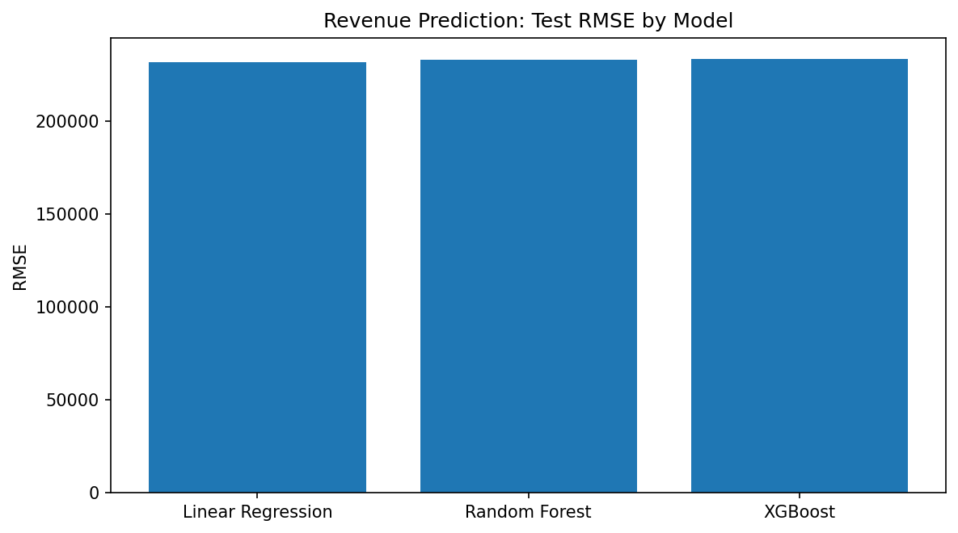
Figure 2. Revenue prediction model comparison using test RMSE.
Model | MAE | RMSE | R²
Linear Regression | 155,284.46 | 231,673.77 | 0.7779
Random Forest | 155,391.99 | 232,970.67 | 0.7754
XGBoost | 155,547.95 | 233,047.25 | 0.7752
Linear Regression was selected as the final Revenue model because it produced the lowest test RMSE (231,673.77) and highest R² (0.7779) among the three revenue models.

Other Regression Targets
Conversions: XGBoost achieved the best test RMSE of 101.0199 and R² of 0.9863.
ROAS: Random Forest achieved the best test RMSE of 1.9682 and R² of 0.8108.
Clicks: XGBoost achieved the best test RMSE of 115.7396 and R² of 0.9987.
The final reusable pipeline uses the saved Revenue regressor because the assignment's primary performance prediction component was implemented as a Revenue prediction model.

9. Model 2 – Campaign Performance Classification
Campaign performance labels were defined using ROAS tertiles. The resulting classes were balanced at approximately one-third each: Low Performing, Medium Performing and High Performing. This converts the continuous ROAS measure into an interpretable business classification target.
Class | ROAS interval | Count
Performance tier | ROAS interval | Training count
Low Performing | 0.032–1.374 | 18,519
Medium Performing | 1.374–3.583 | 18,517
High Performing | 3.583–75.441 | 18,519

Classification Model Comparison
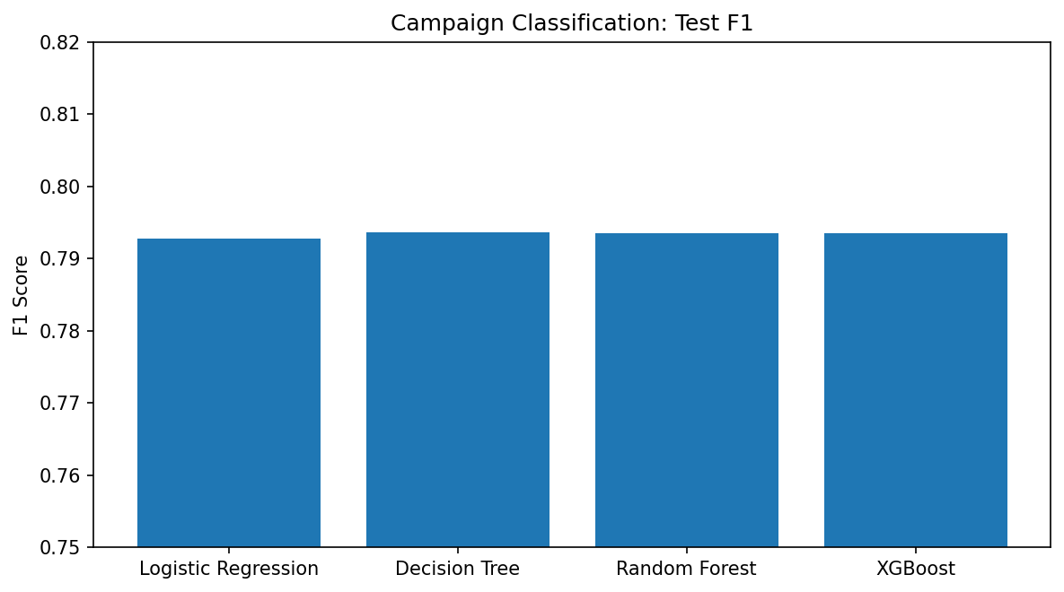
Figure 3. Test F1 comparison for the classification models.
Model | Accuracy | Precision | Recall | F1 | ROC-AUC | CV F1 Mean
Logistic Regression | 0.7916 | 0.7954 | 0.7916 | 0.7927 | 0.9318 | 0.7812
Decision Tree | 0.7905 | 0.8041 | 0.7905 | 0.7937 | 0.9309 | 0.7826
Random Forest | 0.7913 | 0.7988 | 0.7913 | 0.7935 | 0.9317 | 0.7837
XGBoost | 0.7912 | 0.7994 | 0.7912 | 0.7935 | 0.9320 | 0.7829
Random Forest was selected because it achieved the highest mean cross-validation macro-F1 (0.7837) with a low CV standard deviation (0.0044). Its held-out test F1 was 0.7935 and ROC-AUC was 0.9317.

10. Model 3 – Audience Segmentation
K-Means clustering was used to identify behavioural audience groups. The final improved segmentation notebook removed redundant information based on correlation and retained three behavioural features: Engagement Score, Conversion Rate and Lead Rate.
The k-selection analysis evaluated k values from 2 to 8. Although k=2 had the highest silhouette overall, the final selection rule chose k=3 based on the best mean rank within the 3–6 range. This produced three interpretable segments while retaining strong stability.

k | Silhouette | Davies-Bouldin | ARI
k | Silhouette | Davies-Bouldin | Stability ARI
2 | 0.3708 | 1.0554 | 0.9957
3 | 0.3398 | 1.0758 | 0.9892
4 | 0.3130 | 1.0970 | 0.9390
5 | 0.2986 | 1.0603 | 0.9741
6 | 0.2912 | 1.0488 | 0.9870

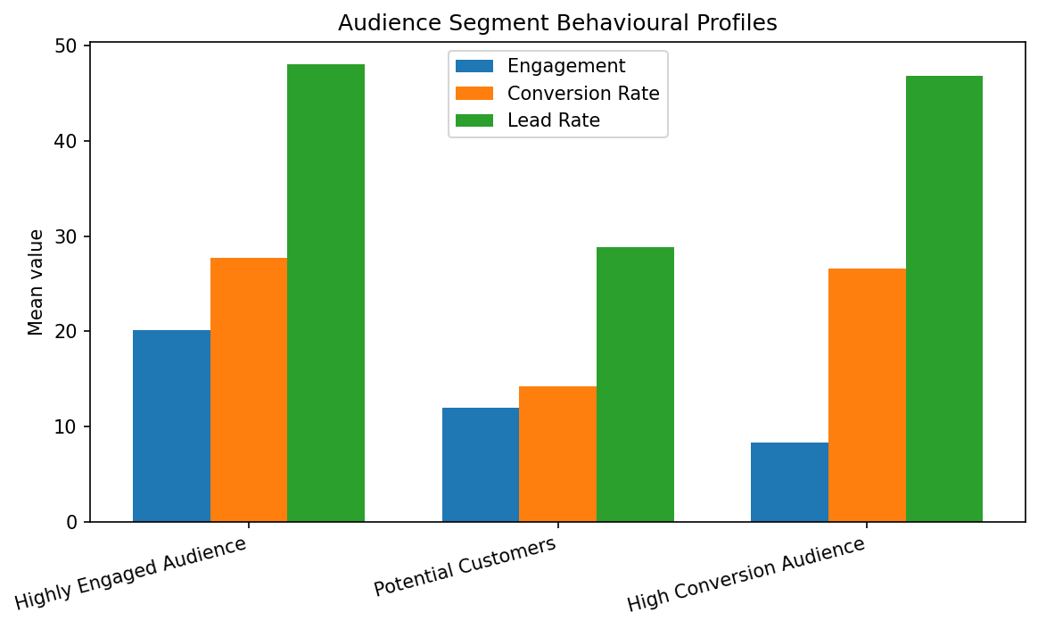
Figure 4. Behavioural profiles of the final three audience segments.

Segment | Count | Share | Engagement | Conv. Rate | Lead Rate | ROAS | CPA
Highly Engaged Audience | 18,608 | 33.49% | 20.15 | 27.72% | 48.03% | 6.28 | 152.23
Potential Customers | 22,544 | 40.58% | 12.01 | 14.27% | 28.84% | 2.34 | 529.26
High Conversion Audience | 14,403 | 25.93% | 8.35 | 26.60% | 46.86% | 2.54 | 430.41

Segment Interpretation
- Highly Engaged Audience: 18,608 campaigns (33.49%). Highest engagement, conversion rate and ROAS in the final segmentation. Recommended action: scale budget selectively and use the segment as a lookalike seed while monitoring frequency.
- Potential Customers: 22,544 campaigns (40.58%). Lower engagement and conversion indicators with lower ROAS. Recommended action: nurture through retargeting, offers and A/B testing to improve conversion.
- High Conversion Audience: 14,403 campaigns (25.93%). Strong conversion and lead behaviour despite lower engagement. Recommended action: raise spend where CPA/ROAS remain acceptable and use stronger creative to improve engagement.
Outcome validation found material differences between segments for ROI, ROAS, Revenue, Acquisition Cost and CPA (epsilon-squared ≥ 0.06), while Spend showed a negligible effect size. This supports the business interpretability of the segmentation beyond cluster labels alone.

11. Model 4 – Marketing Anomaly Detection
The anomaly system combines two complementary approaches. First, robust statistical detection uses median/MAD-based robust z-scores with a threshold of 3.5. Second, Isolation Forest detects unusual multivariate combinations.
The final anomaly feature set was CTR, Conversion Rate, CPC, Spend and ROAS. Redundant features were removed during selection. The system also maps anomaly signals to business-oriented reasons such as sudden CPC increase, significant CTR decrease, unexpected conversion drop, abnormal advertising spend and unusual ROAS.
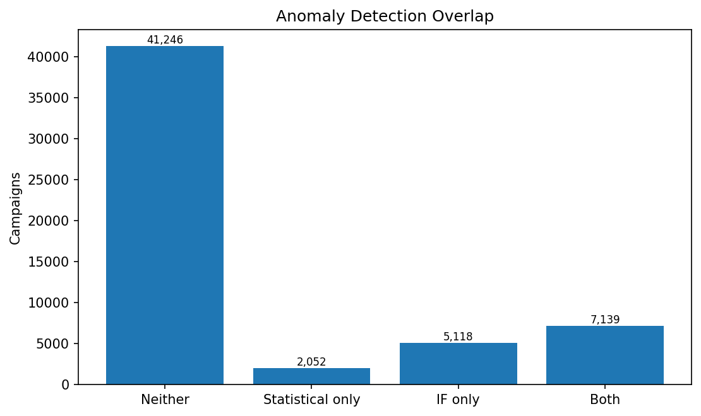
Figure 5. Overlap between statistical and Isolation Forest anomaly detection.
Detection outcome | Count | Meaning
Category | Campaigns | Interpretation
Neither method | 41,246 | No anomaly signal
Statistical only | 2,052 | Unusual single-metric/statistical behaviour
Isolation Forest only | 5,118 | Unusual multivariate combination
Both methods | 7,139 | High-confidence anomaly
Medium confidence | 7,170 | Flagged by one method
High confidence | 7,139 | Flagged by both methods
The final combined output deliberately distinguishes high-confidence anomalies from one-method anomalies. This reduces the risk of treating every unusual observation as a confirmed business problem.

12. End-to-End Prediction Pipeline
The submitted Python pipeline provides a reusable scoring workflow for new campaign data. It loads the trained Revenue regressor, performance-tier classifier and label encoder, audience segmentation artifact, Isolation Forest model and anomaly feature list, plus a reference artifact for robust statistical thresholds.
Stage | Implementation
Stage | Pipeline operation
Input validation | Required numeric/categorical columns, dates, missingness, negative values and logical funnel checks
Feature engineering | Reconstruct Spend and calculate KPIs, temporal, channel and categorical features
Revenue prediction | Load final Linear Regression model
Performance classification | Load final Random Forest + label encoder
Audience segmentation | Apply saved K-Means pipeline and segment mapping
Anomaly detection | Apply Isolation Forest + robust statistical reference
Insight generation | Combine tier, segment, revenue and anomaly information into a marketing recommendation
Output | CSV with predictions, probabilities, segments, anomaly confidence and notes
The pipeline supports template creation, reference construction, self-checking and scoring of new CSV files. The model artifacts are loaded from the models directory and the scoring process reproduces the feature logic used during training.

Pipeline Demo Results
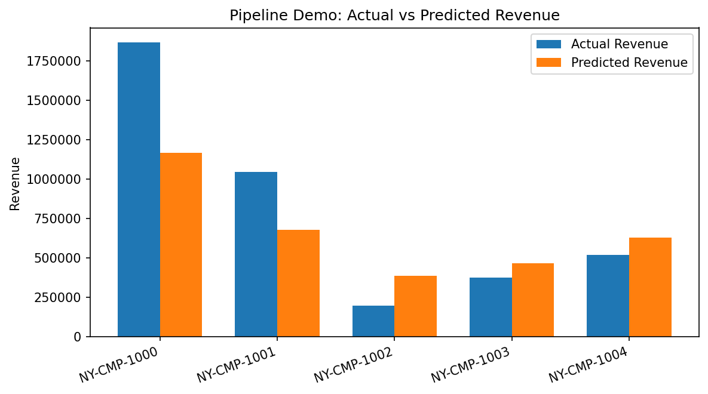
Figure 6. Five-campaign pipeline demonstration: actual vs predicted revenue.
Campaign | Predicted Tier | Audience Segment | Predicted Revenue | Predicted ROAS | Anomaly
NY-CMP-1000 | High Performing | Highly Engaged Audience | 1,166,929 | 4.46 | Medium (one method)
NY-CMP-1001 | Medium Performing | High Conversion Audience | 680,028 | 2.77 | Medium (one method)
NY-CMP-1002 | High Performing | Highly Engaged Audience | 387,344 | 5.66 | Medium (one method)
NY-CMP-1003 | Medium Performing | Potential Customers | 466,775 | 1.98 | None
NY-CMP-1004 | Medium Performing | High Conversion Audience | 630,924 | 2.19 | None
The five-row demonstration produced total predicted revenue of 3,332,000. Three campaigns were flagged with medium anomaly confidence and two had no anomaly flag. The predicted performance tier matched the actual ROAS-derived tier for 60% of the five demonstration campaigns. This percentage is a pipeline demonstration statistic, not a replacement for the full classifier evaluation.

13. Marketing Insights from the Final Pipeline

NY-CMP-1000
Predicted tier: High Performing (72% confidence). Audience segment: Highly Engaged Audience. Predicted revenue: 1,166,929; predicted ROAS: 4.46.
Anomaly signal: Medium (one method) — Unusual combination of metrics. The campaign should be reviewed before making a large budget decision.
Recommended marketing action: High Performing (72% confidence): protect budget and consider scaling. Segment 'Highly Engaged Audience': Scale budget and use as lookalike seed; monitor frequency to avoid ad fatigue. Estimated revenue 1,166,929 (ROAS about 4.46). ANOMALY [Medium (one method)] - Unusual combination of metrics: review the campaign manually; no single metric explains the flag.

NY-CMP-1001
Predicted tier: Medium Performing (62% confidence). Audience segment: High Conversion Audience. Predicted revenue: 680,028; predicted ROAS: 2.77.
Anomaly signal: Medium (one method) — Unusual combination of metrics. The campaign should be reviewed before making a large budget decision.
Recommended marketing action: Medium Performing (62% confidence): optimise creative/targeting before scaling. Segment 'High Conversion Audience': Efficient converters: raise spend where CPA/ROAS hold up; test stronger creatives to lift engagement. Estimated revenue 680,028 (ROAS about 2.77). ANOMALY [Medium (one method)] - Unusual combination of metrics: review the campaign manually; no single metric explains the flag.

NY-CMP-1002
Predicted tier: High Performing (74% confidence). Audience segment: Highly Engaged Audience. Predicted revenue: 387,344; predicted ROAS: 5.66.
Anomaly signal: Medium (one method) — Unusual combination of metrics. The campaign should be reviewed before making a large budget decision.
Recommended marketing action: High Performing (74% confidence): protect budget and consider scaling. Segment 'Highly Engaged Audience': Scale budget and use as lookalike seed; monitor frequency to avoid ad fatigue. Estimated revenue 387,344 (ROAS about 5.66). ANOMALY [Medium (one method)] - Unusual combination of metrics: review the campaign manually; no single metric explains the flag.

NY-CMP-1003
Predicted tier: Medium Performing (75% confidence). Audience segment: Potential Customers. Predicted revenue: 466,775; predicted ROAS: 1.98.
No anomaly was flagged by the combined anomaly system for this demonstration row.
Recommended marketing action: Medium Performing (75% confidence): optimise creative/targeting before scaling. Segment 'Potential Customers': Nurture with retargeting and offers; A/B test messaging to push them toward conversion. Estimated revenue 466,775 (ROAS about 1.98).

NY-CMP-1004
Predicted tier: Medium Performing (78% confidence). Audience segment: High Conversion Audience. Predicted revenue: 630,924; predicted ROAS: 2.19.
No anomaly was flagged by the combined anomaly system for this demonstration row.
Recommended marketing action: Medium Performing (78% confidence): optimise creative/targeting before scaling. Segment 'High Conversion Audience': Efficient converters: raise spend where CPA/ROAS hold up; test stronger creatives to lift engagement. Estimated revenue 630,924 (ROAS about 2.19).

Cross-campaign observations
- NY-CMP-1000 is predicted High Performing and belongs to the Highly Engaged Audience; it is a strong candidate for controlled scaling, subject to anomaly review.
- NY-CMP-1001 is predicted Medium but has an actual High ROAS-derived tier; this indicates a potentially valuable campaign characteristic worth investigating.
- NY-CMP-1002 is predicted High but has an actual Medium tier and an anomaly flag; the model recommendation should therefore be treated cautiously.
- NY-CMP-1003 is consistently Medium and belongs to Potential Customers; the focus should be on improving the conversion funnel.
- NY-CMP-1004 is Medium and belongs to High Conversion Audience; optimization can focus on creative/engagement while preserving conversion efficiency.

14. Model Optimization and Validation
- Five-fold cross-validation was used for supervised model selection.
- Randomized/grid-style hyperparameter searches were used for tree-based models.
- Feature leakage was explicitly checked and target-derived variables were excluded where appropriate.
- Feature correlation was examined to reduce redundancy in segmentation and anomaly detection.
- Classification class balance was checked after ROAS-based label creation.
- Audience segmentation used stability analysis and outcome tests in addition to silhouette/Davies-Bouldin metrics.
- The final saved artifacts were integrated into a single reusable prediction pipeline.

15. Limitations
- The Revenue model has R² of approximately 0.78, so a substantial portion of revenue variation remains unexplained.
- The five-campaign pipeline demonstration is illustrative and should not be interpreted as a statistically sufficient production validation set.
- The segmentation silhouette of 0.3398 indicates moderate rather than perfect cluster separation. the segments are useful behavioural groups, not absolute customer identities.
- The anomaly detector identifies statistical or multivariate unusualness. An anomaly is a signal for investigation, not proof of a business error or fraud.
- The project's reconstructed Spend definition means CPA algebraically equals Acquisition_Cost; this should be documented clearly when communicating KPI results.
- Observed historical funnel variables are available to the Revenue model. Therefore, the pipeline should be interpreted as a campaign intelligence/scoring system rather than a purely pre-launch forecast using only planned inputs.
- The dataset contains observed campaign variation and may not represent future market conditions, platform changes or seasonality outside the covered period.

16. Future Scope
- Introduce time-based validation to measure robustness against future campaigns.
- Add campaign budget, reach, creative attributes, customer lifetime value and platform-level metadata where available.
- Calibrate classification probabilities and evaluate class-specific business costs.
- Experiment with gradient boosting/stacking for revenue prediction if additional data becomes available.
- Extend anomaly detection with time-series baselines and channel-specific thresholds.
- Build an interactive dashboard for campaign monitoring and segment-level decision support.
- Add automated model monitoring, drift detection and scheduled retraining.

17. Conclusion
The completed AI/ML Marketing Campaign Intelligence project demonstrates the full machine-learning lifecycle requested by the assignment. Starting from 55,555 historical campaigns, the project produced a validated cleaned dataset, marketing KPIs, a 53-feature modelling dataset, supervised learning models, behavioural audience segments, anomaly detection and a reusable end-to-end scoring pipeline.
The final supervised models provide a practical combination of predictive and prescriptive analytics: the Revenue model achieves R² 0.7779, while the Random Forest classifier achieves test F1 0.7935. The final segmentation identifies three actionable audience groups with stability ARI 0.9892, and the anomaly component provides a two-method risk signal for unusual campaign behaviour.
Overall, the system converts raw campaign records into actionable outputs: expected revenue, performance tier, audience segment, anomaly confidence and a recommended marketing action. This directly addresses the assignment's goal of applying machine learning to a real-world business problem rather than developing isolated models.

18. Project Deliverables Referenced
Deliverable | Artifact
Deliverable | Artifact used
Raw dataset | nykaa_campaign_data.csv
Cleaned dataset | nykaa_campaign_cleaned.csv
Feature-engineered dataset | nykaa_campaign_features.csv
Segmentation output | nykaa_campaign_segments.csv
Anomaly output | nykaa_campaign_anomalies.csv
Regression comparison | regression_model_comparison.csv
Classification comparison | classification_model_comparison.csv
Segmentation k-selection | audience_segmentation_k_selection.csv
Segment profile | audience_segment_profile.csv
Segment outcome tests | audience_segment_outcome_tests.csv
Pipeline demonstration | scored_campaigns.csv
Final reusable pipeline | marketing_campaign_pipeline.py

